
The Microsoft Data Warehouse Toolkit, 2nd Edition,
with the SQL Server 2008R2 platform

Web Content
Chapter 12 – SharePoint Install Guide

NOTE: This install guide is most likely out of date. Unless you are attempting this with the same editions and versions of software used in this guide, you will most likely have more difficulty than necessary. Search the internet for other installation guides that may be more current, or more aligned with your systems environment. Here are a few candidates:
From MSDN: Considerations for Installing SQL Server PowerPivot for SharePoint
http://msdn.microsoft.com/en-us/library/ee210650.aspx
Step-by-Step SharePoint Server 2010 Installation Guide (with VMware Workstation, which supports 64 bit guest on a 32 bit host)
http://www.codeproject.com/KB/sharepoint/SharePoint_Server_2010.aspx

This install guide repeats some information from Chapter 12 to minimize the need for you to go back and forth while working through the install. So, let’s find an available 64-bit server, set up a 64-bit virtual machine, and get started. The earlier you do this the better because you have a lot to learn about how to get SharePoint working in your DW/BI system environment, and you will make a lot of mistakes.
There is no perfect install order, and you often need to go back and redo some steps before you can move forward with the next step. Therefore, we strongly recommend using a virtual machine for your test environment. One major advantage is that you can take snapshots at the end of each major install step, once you’ve verified the successful completion of that step. This will let you go back to a known good point rather than starting all over if something goes wrong.
Figure 1 illustrates the flow of the install steps you will need to take to get a test installation of SharePoint going along with the other products, add-ins, and SharePoint services that help provide a full featured BI portal. You can install the various components in a different order, but you will have a different set of configurations needed for each install order. There are a lot of steps to this process in the initial release of SharePoint Server 2010 and SQL Server 2008 R2. We hope Microsoft will quickly make this process less cumbersome, and we suggest you check the SharePoint developer center at http://msdn.microsoft.com/en-us/sharepoint/default.aspx for any updates. .
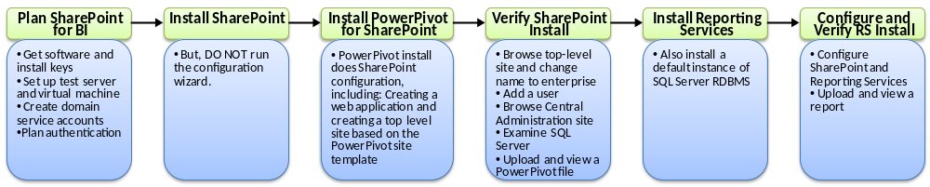
Figure 1 Installation steps for SharePoint and related components
Our assumption is you have a clean version of Windows Server 2008 R2 installed on a dedicated server in an existing domain. Create a virtual machine on this server, also running Windows Server 2008 R2, and make sure you can allocate plenty of memory; 4 or more gigabytes would be good and at least two CPU cores. Note: If you need to create a true standalone installation with its own domain controller, go to http://www.powerpivot-info.com/and search for “single machine”.
Following Figure 1, the remainder of this section starts with a few planning steps, and then runs through the install steps for SharePoint and its supporting products and add-ins, including SQL Server Analysis Services in SharePoint mode and PowerPivot for SharePoint, SQL Server Reporting Services in SharePoint integrated mode for reports. We’ll also talk about supporting steps around access and security and enabling various SharePoint services. Once the base infrastructure is in place, you can do some simple experimentation with PowerPivot and Reporting Services.
In the last part of this install section, we offer you two options to build out the rest of SharePoint’s BI portal related services, both of which require a download from the book’s website. The first option is to create a new site based on a special template created from the site shown in Figure 12.1. The second option is to follow a separate guide to build out the full BI portal yourself. Wait until you’ve had some experience with SharePoint before you decide which option to take.

Plan SharePoint for BI
Before you slip the install disks into your DVD drive, take some time to plan out your installation. Here are several prerequisites for you to think through and get in place first.
Verify software versions and editions. Most of the features we describe here require the enterprise editions of both SharePoint 2010 and SQL Server 2008 R2, or higher. Many BI features will not work with the standard editions, and most will not work with prior versions of these two products. Some features, such as PowerPivot for SharePoint 2010 also require Windows Server 2008 SP2 or Windows Server 2008 R2 as well.
Obtain install files and product keys. Download all the software install files or gather the DVDs you will need ahead of time and have your product keys handy. This includes 64-bit versions of the following:
- Windows Server 2008 R2 (unless your server OS is already running)
- SQL Server 2008 R2 Enterprise edition
- SharePoint 2010 Enterprise edition
If you have an MSDN license, you can get the install files and keys online from the download section of http://msdn.microsoft.com. There are a few other components and add-ins you will download along the way.
Create services accounts in the domain. SharePoint server(s) must be part of a Windows domain to manage network security and accounts. Table 12.1 provides starting point examples of domain account names and permission settings for the test system. Your real install should include additional accounts to support various SharePoint services and IIS application pools, depending on which services you enable and how you want to scale out your farm. You may want to adopt your server group’s account naming conventions.
Table 12.1: Initial Service Account List
Account Name | Account Purpose | When Needed | Rights Needed
SVC_SQL_Admin | SQL Server system administrator | PowerPivot install | Domain user; Administrators group on target server
SVC_SP_Setup | SharePoint setup | SharePoint install | Domain user; Administrators group member on each server in SharePoint farm (except SQL and SMTP); SQL Server login on SharePoint SQL Server computer with securityadmin and dbcreator server roles
SVC_SP_FarmAdmin | SharePoint Farm administrator account | SharePoint install | Domain user; additional permissions added during install; Add to Administrators group for PowerPivot install.
SVC_SP_ServiceAdmin | Service application account | SharePoint configuration | Domain user
SVC_SQL_ASAdmin | Analysis Services service account | PowerPivot install | Domain user
SVC_SP_PwrPvtSvcAppPool | SharePoint PowerPivot application pool account | PowerPivot install | Domain user
SVC_SP_PPSUnattended | PerformancePoint Services unattended service account for data access | PerformancePoint configuration | Domain user; SQL Server login on database server with read access to required data.
SVC_SP_Search | SharePoint search admin account | Search configuration | Domain user; Must have permission in SharePoint to read all searchable content.
Our recommendation is to set these up in Active Directory on your domain and give them appropriate permissions on your test machine right away. This list is a minimum set of service accounts for a single server install. When you set up your official system, you should also create separate service accounts for each SQL Server service and SharePoint service application to properly isolate them. See Chapter 14 for additional service account recommendations. Search technet.microsoft.com for “service accounts required for initial SharePoint deployment” for more detail about the permissions these accounts will need.
Plan authentication and secure store. Windows default authentication mode, called NTLM, does not support the pass-through of user credentials resulting in a login failure if more than two machines are involved in an interaction. This phenomenon, known as the double-hop problem, is common when SharePoint is introduced into the DW/BI system environment because the SQL Server data warehouse database is usually located on a separate server from SharePoint. In this case, a user connects from client machine A to the SharePoint server B, and then selects a report from the BI portal. SharePoint then attempts to connect to SQL Server on server C, at which point the login fails because SharePoint cannot provide enough information for SQL Server to authenticate the user. <> To avoid this, you must switch to a different authentication method called Kerberos if you want to have user-level authentication. Kerberos is considered more secure than the default Windows authentication system and has been part of the Windows environment since 2000. It can be a challenge to configure, but it is getting easier as Windows improves its implementation.
Another option is to use Secure Store Services, which replaces Single Sign On from SharePoint 2007. Secure Store Services provides an option to store credentials in a Secure Store database on the SharePoint server. Credentials are then mapped as user-to-user or Domain Group-to-user and can be renewed at the SharePoint server. Secure Store Services are used in SharePoint to manage PowerPivot data refreshes and other unattended account activity. They require storing a copy of user name and password information in the secure store database.
You don’t need to get Kerberos working for your test SharePoint install. You can avoid the double hop problem by doing your testing on the SharePoint server, perhaps via remote desktop, rather than using a browser from a separate client machine. You will need to figure out your authentication strategy when you build out your SharePoint development and production systems. If you control all the servers you are working with, this is a manageable problem. If others are involved, you are probably facing some negotiations. You also don’t need Kerberos if you are only querying PowerPivot for SharePoint databases. This is because they are hosted within the SharePoint environment and do not require additional authentication.
There are a lot of online guides to getting Kerberos working with SharePoint. This one from the SQL Server Customer Advisory Team, called “Configuring Kerberos Authentication for Microsoft SharePoint 2010 Products,” is particularly helpful: http://go.microsoft.com/fwlink/?LinkID=196600.

Farm Topology and Services for the Test System
Figure 2 shows the topology and environment for the SharePoint test server installation we will be describing. This is by no means a model or recommended topology for anything you might put into production. All three layers of the SharePoint architecture are on one machine. Even if you choose to access data on an existing database machine, the SharePoint test machine will still have SQL Server to host the SharePoint databases. A more robust version of this farm would have two load-balanced front end servers to host the Web Front End (WFE), two load-balanced application servers to host the services layer, a failover cluster setup for the database layer, and perhaps a separate cluster for the Reporting Services component. Let’s set our goals a little lower and see if we can get it all working on one machine first.
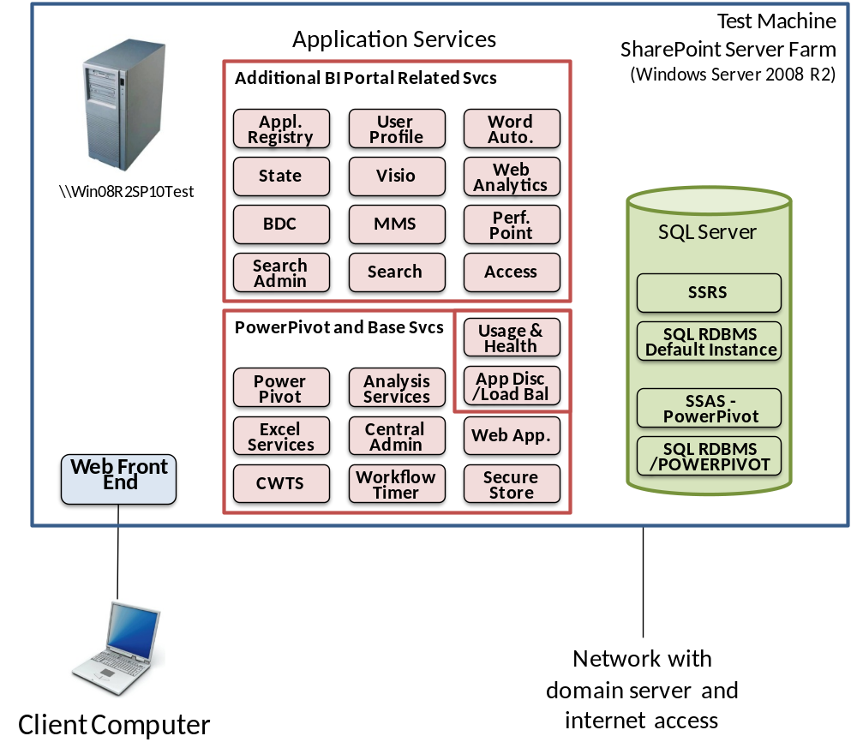 Figure 2 Test SharePoint environment topology and services
We will build out the server following the steps shown back in Figure 1. Because we don’t run the configuration wizard, the initial install step only enables the Web Front End and a few of the service applications. The PowerPivot install step adds the PowerPivot service, the PowerPivot SQL database instance, and the Analysis Services engine in SharePoint mode. The Reporting Services step installs Reporting Services and the default RDBMS instance. Once you get this far, you will be able to work with the core BI functions in SharePoint: PowerPivot and Reporting Services. If you want to explore further, you can download the site template and step-by-step guide from the book’s website and install or enable most of the key features for a full BI portal. Visit http://www.kimballgroup.com/html/booksMDWTtools.html and look under the Chapter 12 heading for the template and guide.
Before you get started with the install, there are a couple of steps that will make the process much easier:
- Make sure you create the service accounts in Active Directory from Table 12.1 on your domain, and add them to the local Administrators group on your server as stated in the table.
- While you’re at it, you need to enable the Desktop Experience feature on your Windows Server 2008 R2 machine. To do this, open the Server Manager console, select Features, and select the Add features link. Check the Desktop Experience box and click Install.
- Turning off Internet Explorer Enhanced Security Configuration will also make your life easier on the test machine. To do this, select the root Server Manager node in the Server Manager to display the Server Summary page. Click the Configure IE ESC link on the right hand side of the page, and select Off under the Administrators section.

Which Comes First, SharePoint or SQL Server?
SQL Server plays several roles in the SharePoint world. It acts as the database engine for the SharePoint admin, content, and property databases. In the case of this book, SQL Server is the data warehouse platform for the relational dimensional model and for the Analysis Services database. SQL Server also provides a separate Analysis Services engine for PowerPivot for SharePoint. Finally, SQL Server Reporting Services is commonly used in an integrated mode with SharePoint to access data kept in a SQL Server data warehouse. All of these roles are installed and configured at different points, and have the potential to cause problems for SharePoint and for the other SQL Server roles.
SharePoint requires SQL Server to hold its metadata databases, so, depending on how you install SharePoint, you either need to enter the name of a pre-existing SQL server instance (typically on a separate machine), or SharePoint, or one of its components, will install a local Express edition instance of SQL Server. You will likely have a separate SQL Server machine to support SharePoint in production; however, we will install SharePoint first and then install PowerPivot for SharePoint, which will create a local SQL Server instance for PowerPivot only on our test system. Later, we will install a default instance of SQL Server on the test machine at the end of the install sequence to allow us to test Reporting Services from SharePoint.
type=”other”

Troubleshooting SharePoint
When SharePoint has a hard time, it will usually display a limited and highly cryptic error message that includes a GUID it calls a correlation ID. You can typically get more information about what the problem is by going to the SharePoint log files, which default to this directory: C:\Program Files\Common Files\Microsoft Shared\web server extensions\14\LOG.
This SharePoint log a good starting point for troubleshooting. Everything is dumped in here; in fact, they call it the Unified Logging Service (ULS), and all service applications and Web Parts can write to the log. So much input makes it hard to find your problem. Use a ULS log viewer tool such as ULS Viewer, which you can find by searching on MSDN. It’s a simple tool, but it does things like grouping messages by correlation ID to help you track down your problem. It’s much easier than reading the logs in Notepad.
Many of SharePoint’s errors also end up in the system application event log. Take a look there if you need more information.

Install SharePoint Server 2010
Before you can actually install SharePoint itself, you need to have all the prerequisite software components in place. The prerequisite install will create and configure Application Server and Web Server (IIS) roles on your Windows 2008 R2 server, and install a whole list of functions to support SharePoint. One of the items it installs, or at least tries to install, is SQL 2008 R2 Reporting Services SharePoint 2010 Add-in. We’ve found it works better to download and install the Reporting Services Add-in separately first, as a prerequisite to the prerequisites.
1. Before you do anything else, make sure you log in to your server as the SharePoint setup account (SVC_SP_Setup, in our case), and that account is in the Administrators group on the local machine.
2. Next, download and install the SQL Server 2008 R2 Reporting Services Add-in for SharePoint from http://www.microsoft.com/downloads. This is actually part of the prerequisites install, but the installer tends to skip it as an “optional component” if it can’t download it.
3. Now you can start installing the SharePoint prerequisites. Start up the SharePoint 2010 install DVD, which should display a SharePoint Server 2010 menu of install items. Select Install software prerequisites from the Install section of the menu.
Examine the messages from the installation to make sure there were no problems. If you see any errors, click the Review the log file link for more details. During various installs we’ve had to download several components and install them manually, usually because the download timed out in the installer. You can find the components with a simple web search. Correct the problems, and re-run the prerequisites install to verify the correction. When you click Finish, the installer may reboot your server to enable all the functions you just installed. If not, you may need to restart the server yourself to allow it to complete any pending installs and clear out any unfinished business. The occasional reboot cleared up several problems during our testing.
Once the prerequisites have successfully installed, you can finally install SharePoint Server. Make sure you have your product key handy.
4. Select Install SharePoint Server on the SharePoint Server 2010 install page and enter your install key for the SharePoint 2010 Enterprise edition.
5. On the installer page titled Choose the installation you want, choose Server Farm. The Standalone option sounds like a test system, but the full server farm configuration is required to support key functions, such as PowerPivot for SharePoint.
6. Next, Choose Complete for the Server Type for the same reason.
7. Select Install Now to get the process going. The install will take a chunk of time, depending on how fast your server is.
Stop at this point. Once the installation has finished, it will offer you the option of running the SharePoint Products Configuration Wizard.
8. Do not run the wizard. Uncheck this box and select Close.
The wizard would set up some elements that conflict with the PowerPivot for SharePoint installer, which is hardwired to do some of the things the wizard would do. Hopefully Microsoft will fix this to make it easier to install PowerPivot on an existing SharePoint server. Check the SharePoint install forum at http://social.msdn.microsoft.com/Forums/en-US/category/sharepoint2010.
You can do everything the wizard would do from the SharePoint Central Administration site, or with Windows PowerShell. You can also run, or rerun, the wizard from the Start ➢ All Programs ➢ Microsoft SharePoint 2010 Products menu later. You can learn a great deal by setting up service applications yourself, but it can also be very frustrating.
At this point, SharePoint is installed, but not configured, so it won’t work yet. You can’t open a SharePoint site or SharePoint Central Administration because you didn’t run the wizard. You still have several steps to go before you have something to show for your efforts.
type="note"
This is a good point to take a snapshot if you are installing on a virtual machine.

Install PowerPivot for SharePoint
Most of the PowerPivot for SharePoint installation guides on the Web assume that PowerPivot is your primary goal in installing SharePoint. In the real world, your organization may already have SharePoint 2010 installed and you only want to add SharePoint to the existing farm. There is a detailed guide for this scenario on MSDN at http://msdn.microsoft.com/en-us/library/ee210616.aspx, although as we said, there are situations where these instructions will fail.
In our case, we are following the easier route of letting the PowerPivot installer configure SharePoint server for us. There is also a detailed MSDN guide for this scenario at http://msdn.microsoft.com/en-us/library/ee210708.aspx. We will outline the major steps and provide a few tips here, but you should refer to the MSDN guide to step you through the process.
PowerPivot for SharePoint installs a separate instance of Analysis Services with a specific name, which it uses as the execution engine for PowerPivot databases. Therefore, the first thing the MSDN instructions have you do is install SQL Server PowerPivot for SharePoint.
1. You need to install PowerPivot under an account that is a local administrator and a SharePoint farm administrator. Add the farm administrator account to the local Administrators security group, and then log in with that account; this is the SVC_SP_FarmAdmin account in our scenario.
At some point you will need another service account to support unattended PowerPivot data refreshes if you have not enabled Kerberos. This is described in more detail in the MSDN instructions.
2. Start up your SQL Server 2008 R2 Enterprise Edition install DVD and run setup as Administrator if it doesn’t autostart.
3. Select Installation from the navigation menu on the left and select New installation or add features... from the list on the right.
4. Run through the install setup steps until you reach the Setup Role page.
5. In Setup Role, select SQL Server PowerPivot for SharePoint, and make sure the Add PowerPivot for SharePoint to: option is set to “New Server”.
6. Accept the defaults on the next several pages until you get to the New SharePoint Farm Configuration page. This is where the PowerPivot installer will perform some of the configuration steps that SharePoint would have done had we let it.
7. Enter the DOMAIN\user name and password of your farm administrator service account, {DOMAIN}\INFODSVC_SP_FarmAdmin in our example.
8. Enter a pass phrase and confirm it. Make note of this passphrase because it is used to secure farm configuration data and you will need it if you ever want to add new servers to the farm.
9. Accept the assigned port number and select Next. (This is the port for the Central Administration site. You will notice it later when you verify the install.)
10. On the Server Configuration page, enter the domain and user names and passwords of the appropriate service accounts. Figure 3 shows the names for our example services accounts on the INFOD domain.
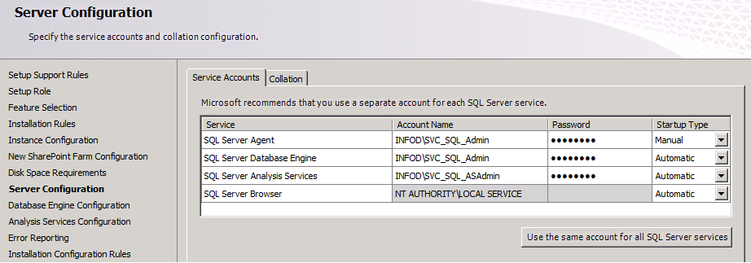
Figure 3: SQL Server service accounts entry page
11. On the Database Engine Configuration screen, select Add Current User to add the farm administrator account to the SQL Server Administrators group. You might want to click the Add... button add your own user ID here as well.
12. On the Analysis Services Configuration screen, select Add Current User, and Add... yourself and any other users who will need to administer Analysis Services.
13. Click Next until you get to the Ready to Install page, then click Install.
The SQL Server installer goes off and installs a SQL Server relational database instance to hold the SharePoint admin, config, and content databases; an Analysis Services instance tied to SharePoint to host PowerPivot databases; and creates two web applications, one for SharePoint Central Administration and one as the top-level website for the server.

Verify SharePoint Install
Let’s step back for a moment and make sure SharePoint is properly installed and working. To do this, we’ll browse the default home page for our new top-level website and add a user ID as a site owner. We’ll also look around the SharePoint Central Administration site, take a look at the databases that have been created in SQL Server, and finally, we’ll examine the roles and features that have been installed in Windows Server 2008 R2, and check for any error messages.

Browse the Top-Level Site
To get started on this, open a browser window or tab and enter the base URL for your server. This is the machine name, http://Win08R2SP10Test/, in our case. The home page that displays should have the title PowerPivot Site - Home. This is because the PowerPivot installer created the top-level site based on the PowerPivot site template. If you get an error, try to load the page again before you do any significant troubleshooting. Sometimes it takes SharePoint a while to get running.
As Figure 4 shows, the navigation panel on the left lists Libraries, Site Pages, Shared Documents, and PowerPivot Gallery. Only the Site Pages link has any content, the rest are empty. When you select the PowerPivot Gallery, it will need to load Silverlight first before it tells you there are no items to show. Remember, Silverlight only works in 32-bit browsers at this point.
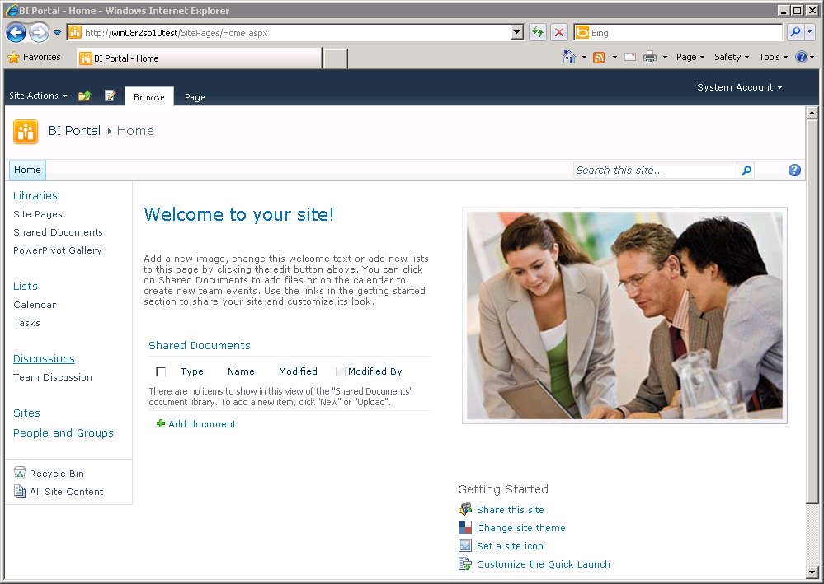
Figure 4: Base home page for the PowerPivot site template
Let’s change the name of this top-level site. Even though it is based on the PowerPivot site template, let’s call it “Enterprise” to signify its role as the overall enterprise portal level. The site name in Figure 4 was set to “BI Portal”, but we will add a separate BI Portal site later.
To change the site name, select Site Actions near the upper left corner and select Site Settings. On the Site Settings page, select the Title, description, and icon link under the Look and Feel heading. Enter the word Enterprise in the Title box and click OK. The root name of the site should now be Enterprise.

View a PowerPivot Workbook
The easiest way to see if the install worked is to run a PowerPivot report from within SharePoint. Rather than go through the steps of creating a report and saving it to the server, we’ll have you can use a test report from the zip file you downloaded with this document.
1. If you don't already have it, go to the book’s website at http://kimballgroup.com/html/booksMDWTtools.html and scroll down to the Chapter 12 section. Download the Chapter12Files.zip file to the desktop on your test server.
2. Open the zip file and drag the file named Simple Cust and Pop Finished Example - Final.xlsx out onto your desktop.
3. Go to your SharePoint top-level site home page (http://win08R2SP10Test/ in our example), and select PowerPivot Gallery under the Libraries heading on the left side of the page.
4. Select the Documents ribbon at the top of the page, and then select Upload Document from the ribbon.
5. Use the Browse button and navigate to the desktop, and select the Simple Cust and Pop Finished Example - Final.xlsx file.
6. Once the file has been uploaded into the PowerPivot Gallery, click the MainReport sheet and it should execute. Select East in the StateGroup slicer. If it doesn't update right away, give it a minute and try again.
When it has finished, you should see a report something like the one shown in Figure 11.7 back in Chapter 11. When confirming that PowerPivot is installed properly, you must either click on a slicer or select the Data menu and refresh the connection. Until you do that, by default, Excel Services is just showing you the contents of the saved pivot table – it does not actually query PowerPivot.

Examine SQL Server
To see what SharePoint did on the database side, open SQL Server Management Studio and take a look at the list of databases in SQL Server. You need to connect to the localhost\POWERPIVOT database instance. Not only did the installer create the SharePoint_Config database, but as you can see in Figure 5, it threw in others to support a few applications, admin, content, and logging.
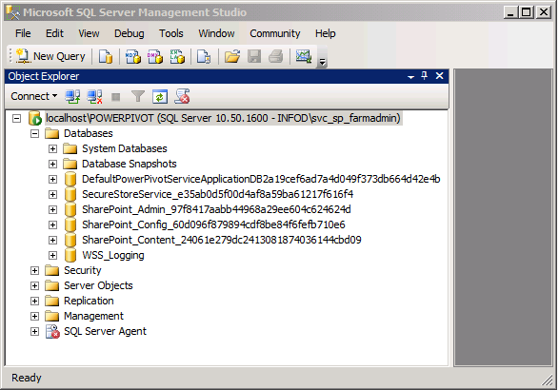
Figure 5: SharePoint databases created at this point in the install
The names are a little strange because when SharePoint creates databases on its own, it appends a GUID on the end of the name to make sure it is unique. These databases demonstrate the importance of the database layer in the SharePoint architecture. Content, definitions, configurations, states, and logs are all kept in metadata in these databases. Like any transaction system, your DBA will need to monitor and manage these databases, or they may grow out of control.

Add a User
In the black bar in the upper right corner of the page, SharePoint lets you know you are logged in as the account you used to install PowerPivot; it says System Account in our case. Try using a browser to access the top-level site from a different machine, where you have logged in under your own user ID. Surprise! You get an error message, or a blank screen, because your ID has not been granted access rights to the top-level site in SharePoint.
To grant access, log in to SharePoint as the SVC_SP_FarmAdmin account and open the top-level home page.
1. Select Site Actions near the upper left corner and select Site Permissions. You should see a SharePoint group called Viewers, which is the default SharePoint group defined in the PowerPivot site template, and any users that have been granted specific access.
2. Select the Grant Permissions button in the upper left corner of the ribbon, and enter your DOMAIN\user ID in the Users/Groups: box.
3. Add yourself to the Viewers [View Only] group in the Add users to a SharePoint group selection, or select Grant users permission directly and select Full Control.
4. Click OK to complete the grant.
Now go back to the other machine and try to view the SharePoint site in the browser.
NOTE
Only the user ID used to install SharePoint has access to its websites by default. You need to explicitly assign access to user groups in SharePoint with the Site Permissions page in the Site Actions menu. You can add the Active Directory groups you should already have set up to the existing SharePoint access groups, or create new SharePoint access groups with the appropriate permission and access levels. For example, if you had an Active Directory group called BI_Users, you could give it read permission in SharePoint by adding it to the [site] Visitors group. More advanced users can be added to the [site] Members group. This allows them to contribute to the site. The DW/BI team can be added to the Designers group, which allows them to make structural changes to the site.
SharePoint offers several other standard security groups out of the box, depending on the site template used to create the site. Experiment a bit to see what works for your organization. You can also add individuals to SharePoint groups directly. Active Directory groups give you more centralized control; SharePoint groups offer a finer grained access control. Active Directory should suffice for most DW/BI systems. See the Microsoft TechNet note: Security planning for sites and content (http://technet.microsoft.com/en-us/library/cc262939.aspx) for more details.

Browse the SharePoint Central Administration Site
The SharePoint Central Administration Site is command central for running your SharePoint farm. From here you can enable new service applications, manage servers and services running on those servers, monitor usage, and much more. To get to the Central Administration site, enter the URL with the port number in your browser. If you neglected to memorize the port number, you can always find a link to the Central Administration site in Start ➢ All Programs ➢ Microsoft SharePoint 2010 Products ➢ SharePoint 2010 Central Administration.
When you connect to the site, you will see a page similar to Figure 6. Note that it follows the portal design patterns we described in the first part of this chapter, with a dense set of links grouped into a collapsed hierarchy of categories. If you know what the categories mean in the SharePoint context, you should be able to find what you are looking for. If you’re not familiar with SharePoint terminology, it’s a bit mysterious.
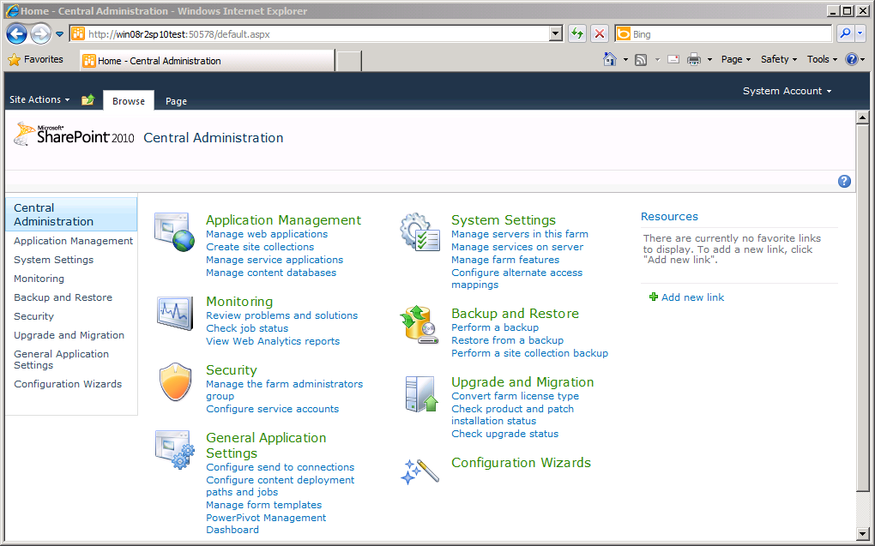
Figure 6: SharePoint Central Administration home page
Click Manage services on server under System Settings to see what services the PowerPivot install starts up for you. The list of services with a status of “Started” should match the list of PowerPivot and Base service applications shown in Figure 2.
At some point, you will likely see a bright red bar across the top of the Central Administration home page. It will say the SharePoint Health Analyzer has detected some critical issues. These will be important in a production environment, but they are usually not relevant to a test system.
You can browse around here a bit if you like, but we will be using Central Admin to set up a few services soon.

Check Server Manager
Finally, take a look at the server events using Windows 2008 R2 Server Manager. Open Server Manager under Administrative Tools in the Start menu and expand the Roles heading. If you started with a clean Windows Server 2008 R2 install, you should see at least two roles: Application Server and Web Server (IIS). Click on each role in turn. If all went well, you should only see information events posted to each role. If you see other errors, you should dig into them and get them fixed, although the common errors will not directly impact your use of SharePoint in this test environment.
Congratulations! You now have the core SharePoint system and services up and running. However, there are still some key BI services and features that you need to enable as part of the set up.
type="note"
If you are running on a virtual machine, now is a good time to take another snapshot.

Install SQL Server Reporting Services
Next we will install Reporting Services along with the default instance of SQL Server to give you a chance to create some reports and display them on a SharePoint page. Remember, the relational database and Reporting Services would typically be installed on a separate machine (or machines). In fact, the SharePoint Health Analyzer will flag SQL Server on the same machine as a problem.
Pull out your SQL Server DVD again, and install SQL Server with the relational database and the Reporting Services features selected. You should be able to move through this install without detailed guidance. Here are the key points in the install process and the parameters you’ll need:
- From the SQL Server Installation Center window, select the Installation link on the left and select New installation or add features to an existing installation on the right.
- When you reach the Installation Type page, leave New installation or add shared features selected.
- When you reach the Setup Role page, leave SQL Server Feature Installation selected.
- Select the following on the Feature Selection page:
- Database Engine Services
- Reporting Services
- Business Intelligence Development Studio
- Client Tools Connectivity
- Select Default instance on the Instance Configuration page.
- Enter the appropriate service account for each service on the Server Configuration page. We used {domain}\SVC_SQL_Admin for all three services for our test server.
- Select Add Current User and add any other IDs you’d like to have access on the Database Engine Configuration page.
- Select Install the SharePoint integrated mode default configuration on the Reporting Services Configuration page.
The rest of the SQL Server install choices should be straightforward.
Verify the Database Install
Once the database install is complete, verify that it is working by opening SQL Management Studio and connecting to the default instance of the database engine on the localhost server name (not the POWERPIVOT instance). If you click the Databases tree, you should see the two Reporting Services databases. Select New Query and run the following SQL against the master database:
SELECT C.session_id, login_name, auth_scheme, connect_time,
program_name, client_interface_name
FROM sys.dm_exec_connections C
JOIN sys.dm_exec_sessions S
ON C.session_id = S.session_id;
This query should return a several rows; some for your current SQL Studio connection, the query connection, and Reporting Services. Note that they are all probably using NTLM as their authentication scheme. This query will be useful when you transition to your implementation environment and want to verify Kerberos authentication.

Complete the Reporting Services Integration
These last few steps will configure SharePoint to work with Reporting Services.
1. Run SharePoint Central Administration from Start ➢ All Programs ➢ Microsoft SharePoint 2010 Products.
2. Select General Application Settings in the left navigation bar.
3. Select the Reporting Services Integration link under the Reporting Services heading and fill in the settings:
- The Report Server Web Service URL should be http://{MACHINE}/ReportServer. If this doesn’t work, open the Reporting Services Configuration Manager in the SQL Server 2008 R2 program group, and look at the Web Service URL link.
- In the Authentication Mode section, select Windows Authentication.
- In the Credentials section, enter the domain and user name of the SQL Server admin account — {DOMAIN}\SVC_SQL_Admin in this case.
- Select Activate the feature for all existing site collections and click OK.
4. You should see a Reporting Services Integration Summary page with successful indicators next to each integration step.
5. Back in General Applications, select Set server defaults under Reporting Services. There is no need to change any of the defaults for our purposes, but it is helpful to review the settings. Cancel when you are finished.

Verify Reporting Services Install
The easiest way to see if the install worked is to run a report from within SharePoint. Rather than go through the steps of creating a report and saving it to the server, we’ll have you download a set of files that includes a test report, and several other files you will use in the next section.
1. Open the zip file you downloaded from the book’s website earlier in this chapter and drag the file named CPU_Time_by_User.rdl out onto your desktop.
2. Go to your SharePoint top-level site home page (http://win08R2SP10Test/ in our example), and select Shared Documents under the Libraries heading on the left side of the page.
3. Select Add document in the center pane, Browse to the desktop, and select the CPU_Time_by_User.rdl file.
4. Once the file has been uploaded into SharePoint, click its name and it should execute.
When it has finished, you should see a report something like the one shown in Figure 7.
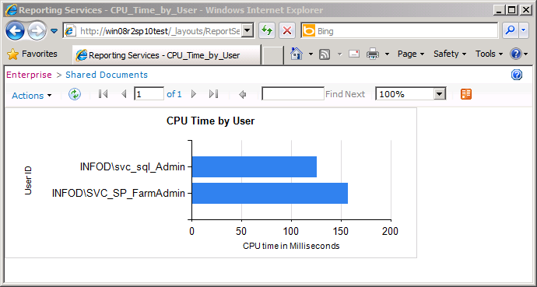
Figure 7: Evidence of a successful Reporting Services integration with SharePoint
type="note"
Once again, if all has gone well and you are using a virtual machine, now is an excellent time to take a snapshot.

A Fork in the Road
At this point, you have the core capabilities enabled in SharePoint to build a basic BI portal. You can offer Reporting Services reports and PowerPivot reports to your user community from a common interface. You can learn a lot about SharePoint by experimenting with your test server in its current state. You did good work.
However, you still have a long way to go before you have a fully functioning BI portal to unveil at the first user deployment education session. If you want to learn all the details, you can continue from this point and install PerformancePoint, enable a whole range of useful services and content types, and create your portal home page along with the site theme and layout. This is the best path to take if managing SharePoint will be one of your jobs, or if you are truly interested in understanding how SharePoint works and what you can do with it.
The individual steps for this detailed installation are in a document titled SharePoint BI Portal Install Completion Step-by-step.doc in the zip file you downloaded. We encourage you to pull them out and work through them to get the full SharePoint experience.
Alternatively, if you don’t need to learn all the installation details, you can still get the full experience by creating a new SharePoint site with the BIPortal template included in the zip file you downloaded in the last step, which will do most of the setup and configuration for you.
The steps for installing the template are also included in a file in the zip file called SharePoint BI Portal Template Install Steps.doc.
The end result of either path is a full featured BI portal site.

The Added Functionality of the BIPortal Site Template
Both the BI Portal site template and the step-by-step guide enable many features that are not grouped together in the standard templates found in SharePoint. We started with the BI Center template and added on the following features, each of which requires several steps to enable within SharePoint:
- PerformancePoint dashboard and scorecard capabilities
- Search across the portal environment
- Announcements to provide information to users
- Web-based surveys
- User support discussion groups
- User support request database
- Alerts to notify users when documents or other items of interest change
- User personalization capabilities (my reports, custom layouts, and so on)
- A workflow to manage user submission and approval of reports and PowerPivot analytics
- Group work lists including calendars and team resource scheduling tools
In addition to these features, there are the actual pages that make up the portal: the home page, sub-pages for the enterprise business process reports, and supporting pages for documentation and user support, along with the navigation links on the left side of the site.
The point is, there is a lot more work to do. By using the BIPortal site template, you will be able to experiment with all this added SharePoint functionality, but you will not gain a good understanding of how it got there. If you are going to use SharePoint as your BI portal and application delivery platform, you, or someone else on the BI team, will have to learn the details of how to make it work. That’s where the detailed step-by-step approach will help.

Exploring SharePoint
Once you get the BI Portal site template loaded, or go through the steps to build it out yourself, you should spend some time playing around with it. Upload some of your own PowerPivot examples and see what they look like in SharePoint. Try to create a report in Report Builder. Try to edit a SharePoint page in SharePoint Designer. Experiment with the PerformancePoint Dashboard Designer. Work with security groups a bit to see how you tie them to Active Directory.
The best way to do this would be to create a beta version of your own BI portal. Start working on your standard page layouts, color themes, navigation bar, user documentation, and user interactions. This will likely take a couple of weeks, so make sure it is built into the project plan.

